EXP NO 10: Student Information Management
Aim:
To create a cloud-based Student Information System using Zoho Creator.
Steps:
- Create a new application.
- Create a Student Information form.
- Add fields: Student Name, Register Number, Address, Phone Number, Age, Course, Grade, Attendance Report, Progress Report, and Semester Mark Sheet.
- Create reports to view student information.
- Enter sample records and verify the application.
IMPLEMENTATION:
// Student Information Management System

student = insert into Students
[
Student_Name = input.Student_Name
Register_No = input.Register_No
Department = input.Department
Year = input.Year
Email = input.Email
Phone = input.Phone
Address = input.Address
];

info "Student information saved successfully.";
OUTPUT:
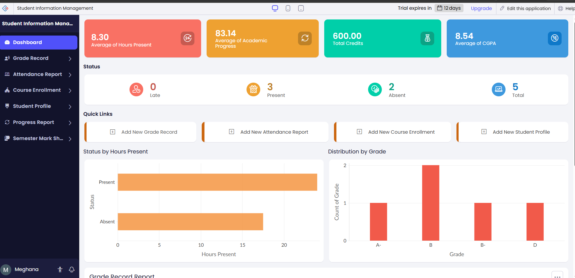
RESULT:
The Hospital Information System was successfully implemented in Zoho Creator to manage patient details, doctor information, admission details, disease records, and discharge status.

